April 19th - Weekly Update
Front-End Team [ Prasanna and Kavya ]

- Move from one image to next image, only that image corresponding polygons to be displayed in right panel.
- Edit of group id of annotated object to be added in setup.
- Delete of the individual annotated component.
- Save as json to be added to tool.
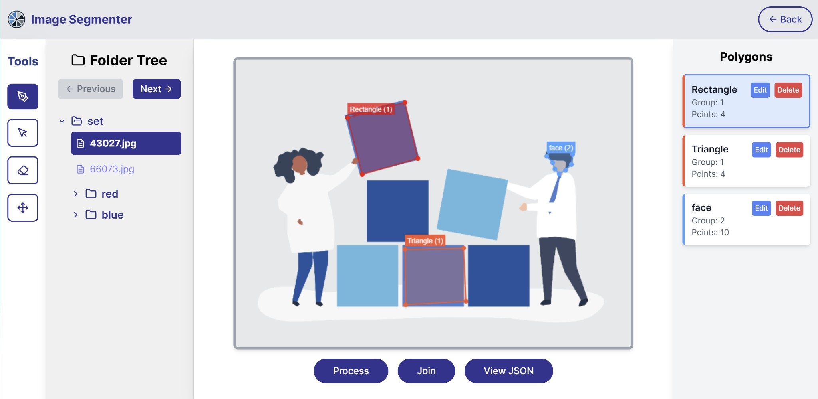

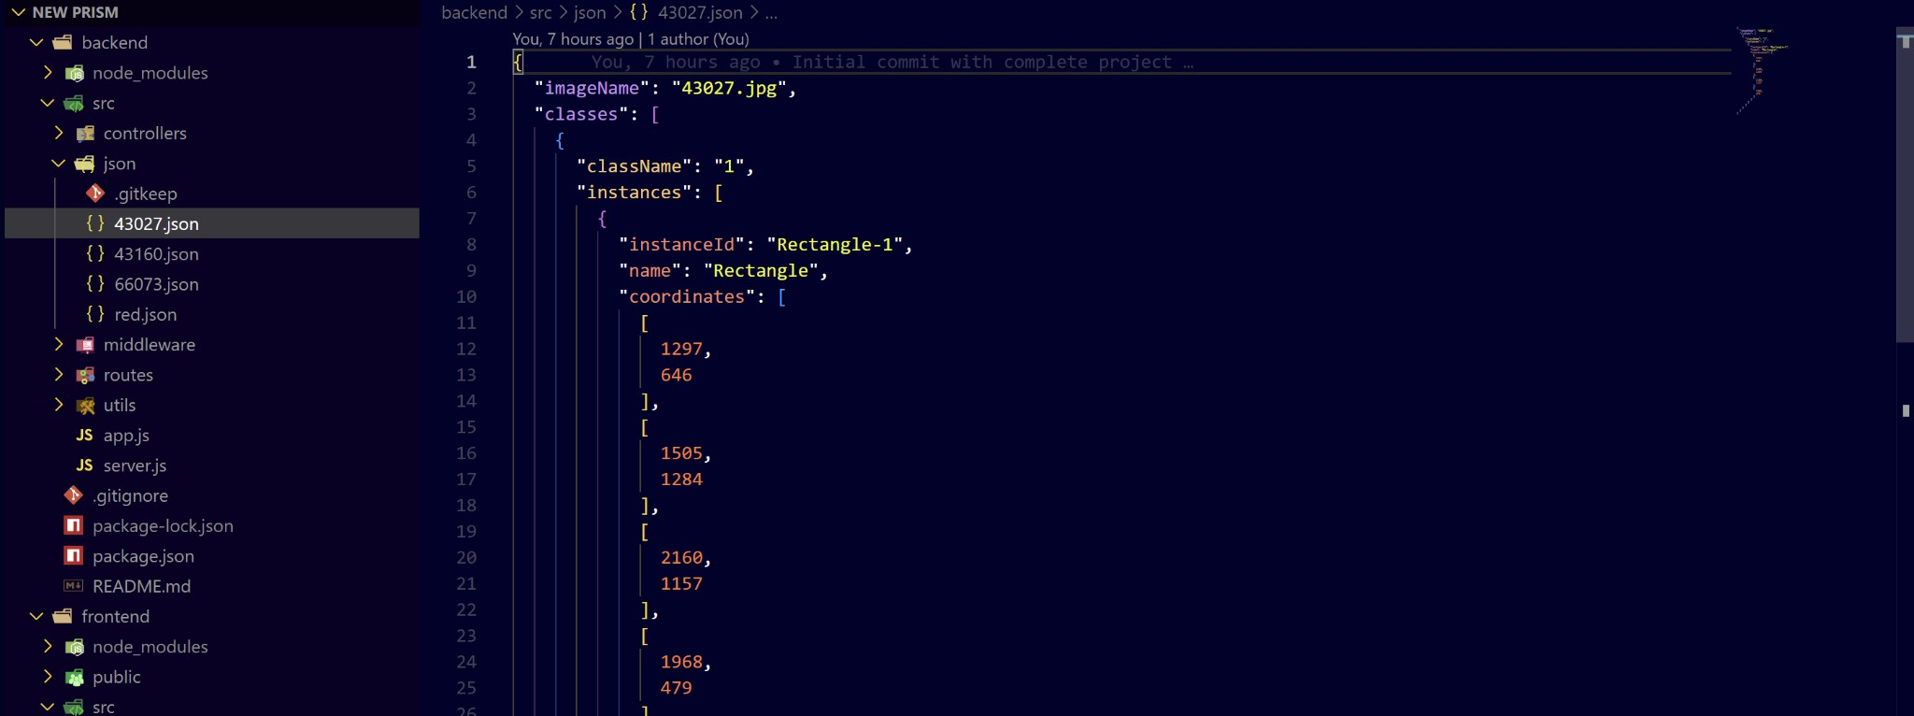
Next Steps
- Once someone restarts the tool, the tool will load the json if it is already annotated and display that output.
- Zoom and unzoom operation of the canvas.
- Point to mask and mask to point facility to be added to tool.

Back-End Team [ Aravinthakshan and Janak ]

- Finished API for consecutive image xmem processing.
